CISC2005 – Lab 6

WONG KAI YUAN (DC026157)

1. Screenshot :



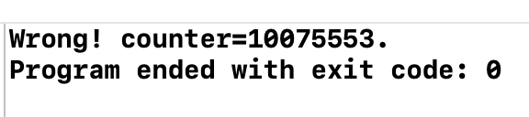

(after changing the iteration)  
Answer :

* 1. Why the counter value is "Wrong"?   
     The program is intended to make counter value = 2N, since each thread will increase counter by N. Therefore, it should output counter = 2N and “correct”. However, counter value is “Wrong”, and from the screenshot, we can see that counter value is different. The reason is 2 threads might not be in the sequence we desire, which is one by one. In fact, the 2 threads may run together, and obtain the same global value of counter, and the result is, counter will not be 2N as we expected.
  2. What happens if the number of iterations is reduced?  
     When (N) number of iterations is reduced, there is higher chance of “correct”, because the running time is too fast. But note there will still be chance of “wrong”. To conclude, we cannot make sure 100% the counter value is “correct” even the number of iterations is reduced if we didn’t protect our global value.

1. Screenshot :   
   A picture containing shape

   Description automatically generated  
   Answer :   
     
   2.1 Please complete the code for the alternation algorithm.   
   name : Q2.c  
     
   2.2 Why does it satisfy the mutual exclusion?   
   It satisfy the mutual exclusion by 1 easy method, which is using variable turn 1 & 0 (in my case, I use 1&0, textbook use 1&2). The 1st thread can only run if it’s his turn, else, it will be waiting for its turn on the while loop. This same goes to 2nd thread. This is one easy mechanism to satisfy mutex.   
     
   2.3 What are the drawbacks of the alternation algorithm?  
   There are mainly 2 drawbacks of this alternation algorithm. 1st, it violates progress, the thread could go into infinite loop outside of the critical section. Second drawback is it only applicable for 2 threads, if more than 2 threads, it’s not as convenient to implement.
2. Screenshot :   
   Text

   Description automatically generated with low confidence  
   Answer :   
     
   3.1 Please complete the code for the Peterson’s algorithm.   
   name : Q3.c  
     
   3.2 Why does it satisfy the mutual exclusion?  
   It satisfy mutual exclusion by using both variable of turn & flag to make sure only one thread can run each time. Hence, satisfying mutual exclusion.
3. Screenshot :   
   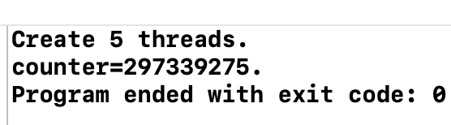 (first algorithm)  
   Text, application

   Description automatically generated (second algorithm)  
   Answer :   
   4.1 What's the difference between the 2 lock algorithms in the "acquire" function?   
   The first lock algorithm have a problem where the implementation of locks has critical sections. But the second lock algorithm makes sure that the implementation is atomic by help from hardware, which is the atomic instruction (test-and-set).  
     
   4.2 Does the 1st algorithm work? Why?   
   Nope, because the implementation of locks has critical sections too, and resulting in race condition.  
     
   4.3 Does the 2nd algorithm work? How does the "test and set" operation work?

Yes, it works. Test and set operation make sure it’s executing atomically by record the old value, set the value to TRUE and return the old value.